**Lab Report 7**

## **Aim**

Image segmentation in MATLAB.

## **Theory**

Image registration is a technique used to align two or more images of the same scene taken at different times, viewpoints or by different sensors. In MATLAB, there are several ways to perform image registration. Here is a general overview of the steps involved in image registration using MATLAB: Load the images: The first step is to load the images that you want to register using the imread function in MATLAB. Pre-processing: Depending on the quality and size of the images, pre-processing may be necessary. Common pre-processing techniques include filtering, resizing, and normalization. Feature detection: The next step is to detect features in the images that can be used for registration. MATLAB has built-in functions like detect SURF Features and detect BRISK Features that can be used for feature detection. Feature extraction: After detecting features, the next step is to extract descriptors that can be used to match the features in the two images. MATLAB provides functions like extract Features to extract descriptors. Feature matching: The extracted features and descriptors are then matched using functions like match Features in MATLAB. This step aims to find the corresponding points between the two images. Transformation estimation: Once the corresponding points are found, a transformation model is estimated to align the two images. MATLAB has functions like estimate Geometric Transform and fitgeotrans for transformation estimation. Image registration: Finally, the registered images are obtained by applying the estimated transformation to one of the images. The imwarp function in MATLAB can be used for image warping.

Image registration:

• Overlapping 2 images so that we can visualize the differences between the 2 images.

• Applications - What are the effects of a drug that can be visualized by overlapping 2 images.

1)Different transforms:

a) Affine transformation:

i. Scaling

ii. Rotation

iii. Translation

iv. Changing the transparency of the base image/registered image

2)Basically there are 2 images:

a) Base Image (Untreated/before)

b) Unregistered image (After treatment)

3)How to do scaling:

a) Mark 3 non-collinear points which we feel have not varied much in base and unregistered image.

b) Take the Euclidean distance between any 2 of these points in both images. (base image - d1 , unregistered image - d2)

c) Scale the unregistered image so that it can be overlapped. Scaling Factor =d1/d2)

4)How to do rotation:

• Take three points in each image

• Find the angle between the two lines in both images using theta = tan^(-1) (y2-y2/x2-x1)

• Rotation angle = | theta2 - theta1 |

5) How to do translation:

• Take the same three points in both the base and the unregistered image.

• Here we are going to shift the origin of the unregistered image

• Take a point on the base image, then take the same point in the unregistered image.

• How these 2 images should have the same spatial location for being overlapped.

• Hence we shift the origin of the unregistered image so that the point in the unregistered image should have the same spatial location as the base image.

##### **CODE**

% IMAGE REGISTRATION

i = imread("ok.png");

text(size(i,2),size(i,1)+15, ...

'Original Image 1','FontSize',7,'HorizontalAlignment','right');

unregistered = imread("cut.png");

text(size(unregistered,2),size(unregistered,1)+15,'Image 2','FontSize',7,'HorizontalAlignment','right');

[movingPoints,fixedPoints] = cpselect(unregistered,i,'Wait',true);

t = fitgeotrans(movingPoints,fixedPoints,'affine');

Rfixed = imref2d(size(i));

registered = imwarp(unregistered,t,'OutputView',Rfixed);

subplot(1,3,1);imshow(i);

subplot(1,3,2);imshow(unregistered);

subplot(1,3,3);imshowpair(i,registered,'blend');

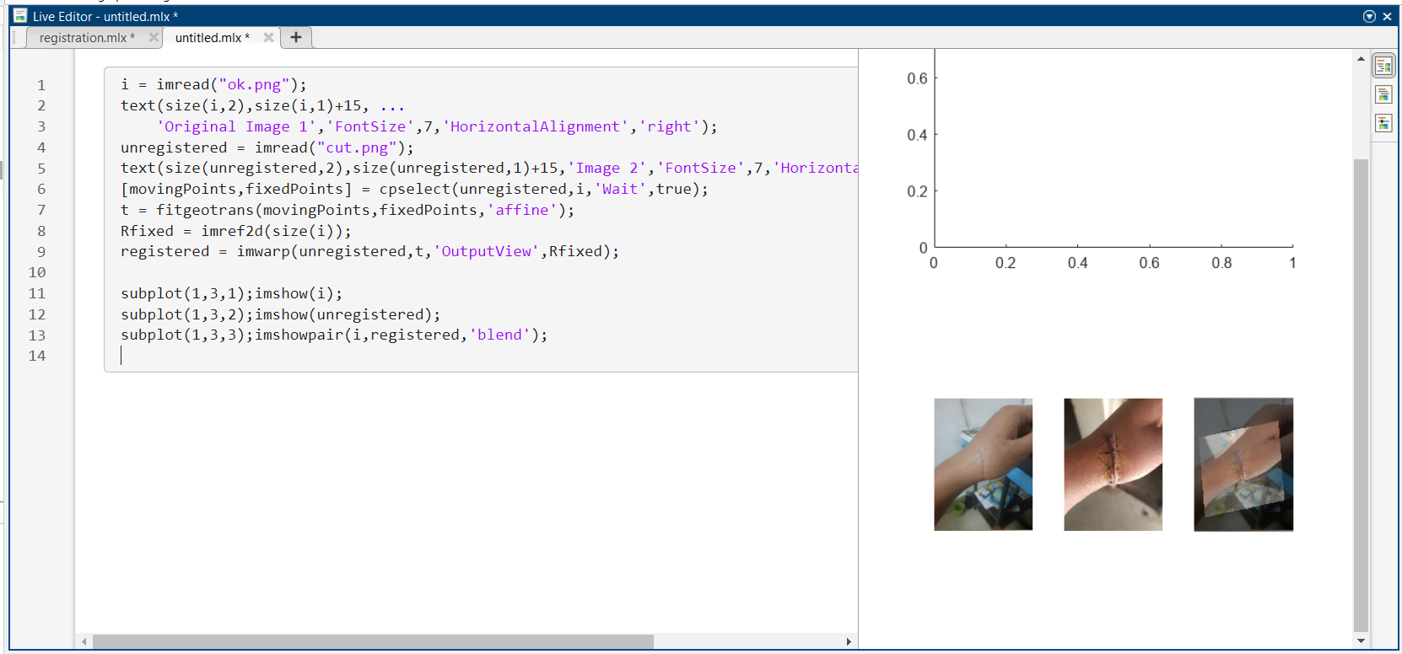

Figure 1: image registration in MATLAB

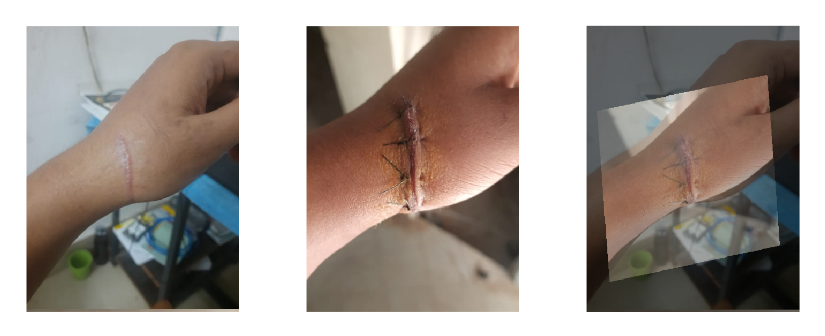

*Figure 2: image registration of injured and healed hand in MATLAB*

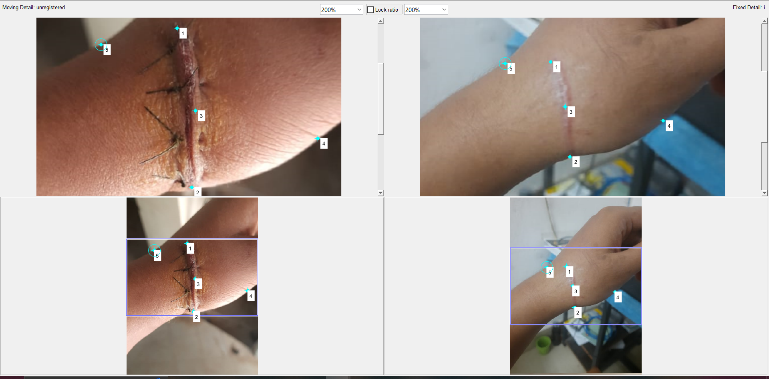

*Figure 3: point selection for image registration of injured and healed hand in MATLAB*

---------------------------------------------

Shreenandan Sahu |120BM0806